PSHE
Across our Speak Out Stay Safe sessions, Pioneers learn how to keep themselves safe and who to talk to if they are worried. They begin by creating a safe and supportive circle and learning key words about feelings and safety.
Through a series of stories, pupils learn that bullying, hurting others, emotional abuse, sexual abuse and neglect are all wrong. They practise recognising unsafe situations, saying a strong “no” or “stop,” and identifying trusted adults in their safe circle.
Pupils also learn about private body parts, the difference between good and bad secrets, and the importance of speaking out if something doesn’t feel right.
RE
The Pioneers will continue to look at What helps people decide what is right and wrong and learn about the religions of Buddhism, Christianity and Humanism.

Performing Arts

Design Technology – Dragonflies.

For the spring term, Pioneers will be learning about simple mechanisms, with a focus on sliders and how they help objects move in a straight line. Pupils will begin by identifying everyday items that use sliders, such as drawers, pop-up books, and toys, and explore how these mechanisms help objects move smoothly and predictably. They will test and observe how sliders work within pictures, seeing how movement can bring a design to life. Using this understanding, children will design their own moving picture or model that includes a slider, carefully planning how movement will enhance the final product. They will then create a final piece that demonstrates different types of slider movement, using simple materials and safe joining techniques.

Food Technology – Butterflies.

Pioneers will investigate existing wrap recipes and nutritional information, plan their own combinations, experiment with flavourings and textures, and take responsibility for measuring and preparing ingredients safely. By the end, they will have designed, made, and evaluated their own personalised healthy wrap recipe.

Art
The Pioneers will be using design thinking and problem-solving to create more complex 3D card models.

Music
In this unit, Pioneers learn that music is made up of sound waves that travel through the air. They explore how we can feel music through vibrations, as well as hear it. Pupils also look at the patterns that music creates, helping them to understand that sounds can be organised in different ways to make music.

P.E
Pioneers will take part in simple team games such as benchball, netball, tag rugby, basketball and uni-hoc. During these activities, they will practise important physical skills like running, jumping, throwing and catching, both on their own and with a partner. They will also begin to use simple tactics to try to beat an opponent. The main focus will be on playing fairly, following the rules and learning how to keep score.

`

The Ice Age – Pioneers
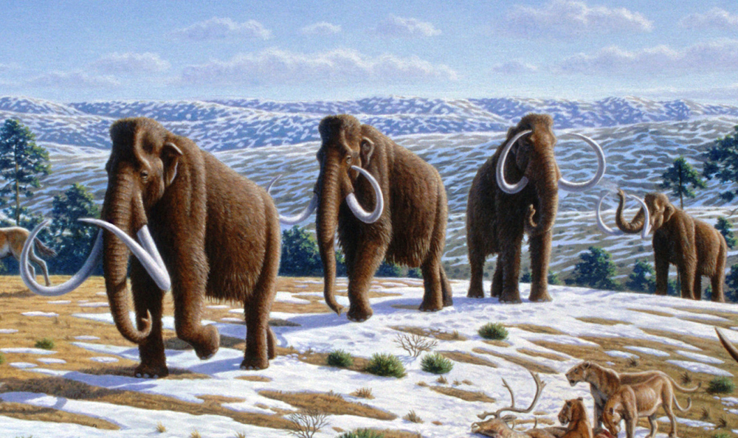
Spring Term 2.

Science
In this unit, Pioneers will learn more about food and how it helps keep their bodies healthy. They will explore what a balanced diet looks like and find out about different food groups and how they help the body.
Pioneers will learn that food gives us the energy and nutrients we need to grow, stay strong and feel our best. They will also talk about how different foods can affect their energy levels and overall health.

As part of the unit, Pioneers will be encouraged to try some new foods and talk about how they feel about them, including what they like or dislike. The aim is to help Pioneers begin to think about their food choices and learn how to make healthy decisions.

Humanities – History and Geography.
Building on their curiosity, the Pioneers will dive deeper into the world of the Ice Age. They will learn when the Ice Age happened, what the land looked like, and how both animals and people adapted to survive. Children will explore tools, hunting, and shelters in more detail, and discover how the Ice Age eventually ended. Using maps, timelines, stories, and creative work, children will develop their historical thinking, compare past and present, and share their knowledge in exciting ways.

Computing.
In this unit, Pioneers will explore the idea of sequencing in programming using Scratch. They will be introduced to different blocks, such as motion, sound and event blocks, and use them to create their own programs by putting steps in the correct order.
As a final project, Pioneers will create a simple piano program. The unit is taught at a steady pace so they can build their understanding of sequences step by step. They will also learn about the different stages of planning and designing a program.

